**S.O.L.I.D. Principles Of Object Oriented Programming**

SOLID principles are a set of principles that are used in Object Oriented Programming.

They set the standard of how to write the programs in any Object Oriented Programming language.

SOLID principles help to write a program that can more easily respond to changes, are easy to maintain and cost less time to work with.

SOLID principles can be applied to any OOP program.

SOLID principles are actually a set of 5 principles that are :

1. **S.R.P (Single Responsibility Principle)**
2. **O.C.P (Open/Closed Principle)**
3. **L.S.P (Liskov Substitution Principle)**
4. **I.S.P (Interface Segregation Principle)**
5. **D.I.P (Dependency Inversion Principle)**

Here we will take a deep dive into the first three principles and will understand their implementation with the help of code examples.

**L.S.P (Liskov Substitution Principle)**

Liskov substitution principles define that the object reference of a superclass shall be replaceable with objects of its subclass without breaking the application.It states that :

**“If S is a subtype of T, then objects of type T may be replaced with objects of type S (i.e., an object of type T may be substituted with any object of a subtype S) without altering any of the desirable properties of the program”.**

Functions that use references to base classes must be able to use objects of the derived class without knowing it.

**Liskov Substitution principle (LSP)** is a particular definition of a subtyping relation, called (strong) behavioral subtyping.

In other words, a subclass should completely inherit the behavior of its parent class and their objects are replaceable with the base class object without making any unintended modifications.

LifetimeMember Class is a subtype of class Member that is overriding the parent class addToDatabse method .

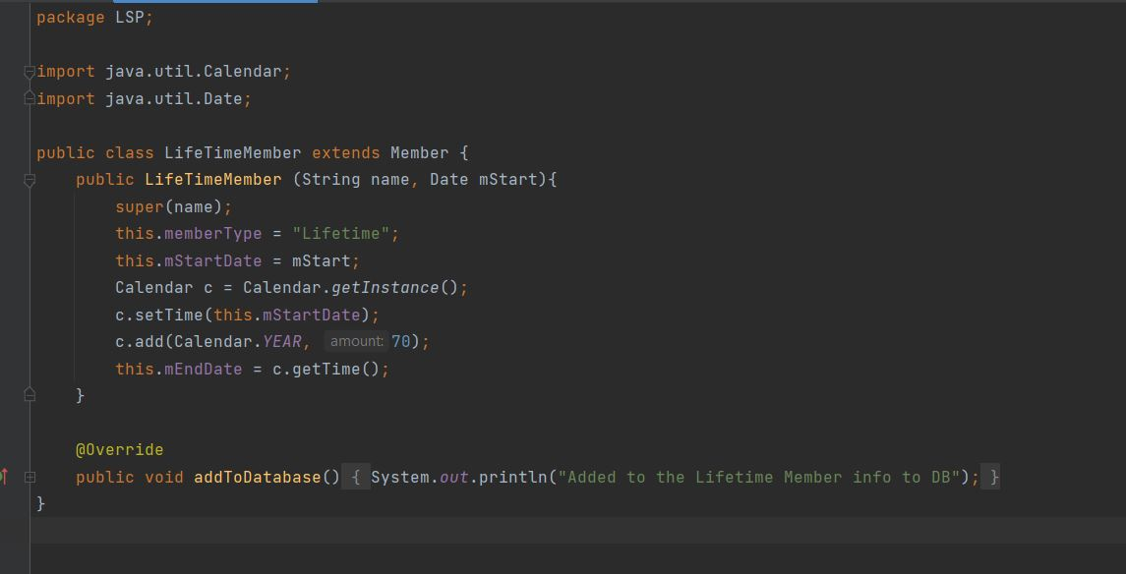

Now to check whether the above example is following LSP principle or not we require a main class. So let’s see our main class ---

Here in the main class we have made a list of parent type i.e. “**Member”** class but at the run time we are assigning it with the instance of children classes.

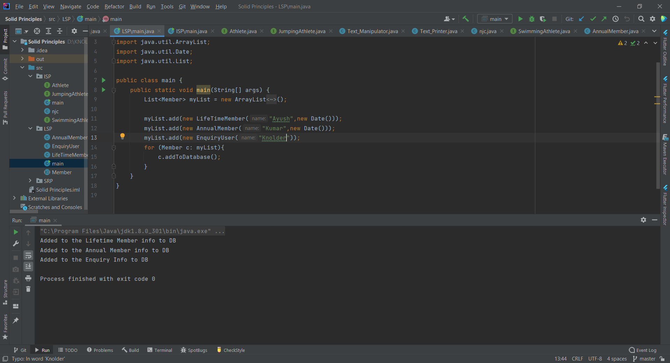

In the loop we are running the “**addToDatabase ''** method over each member of the list to check for the LSP and the code worked flowlessly, hence satisfying the **Liskov Substitution Principle.**

Now if we add a **“addBooking”** method in the “**Member”** class then the subclass “**EnquiryUser”** would not be able to substitute this method completely as the Enquiry User does not make booking and overriding that method will have different behavior of that method in the subclass and this will violate the **Liskov Substitution Principle** that says a “**child class should completely substitute its parent class**”.

To achieve LSP is such a case we can make use of Interface to implement the method “**addBooking**” and subclasses will implement the method as per use.

**S.R.P (Single Responsibility Principle)**

The **single-responsibility principle** states that a class, module or function should perform only one job. In other words, it should have all the responsibilities of a single functionality.

Martin explained this by saying **“a class should have only one reason to change”**. Here the “reason” is that we want to change the single functionality this class pursues. If we do not want this single functionality to change, we will never change this class because all components of the class should relate to that behavior.

SRP makes it easy to maintain the code as a class has only one responsibility and so when changing any functionality related to that class responsibility requires only a single class to modify.

To achieve the SRP we will have to separate the printing responsibility by making a separate class for printing related tasks.

Lets see how we can do this:

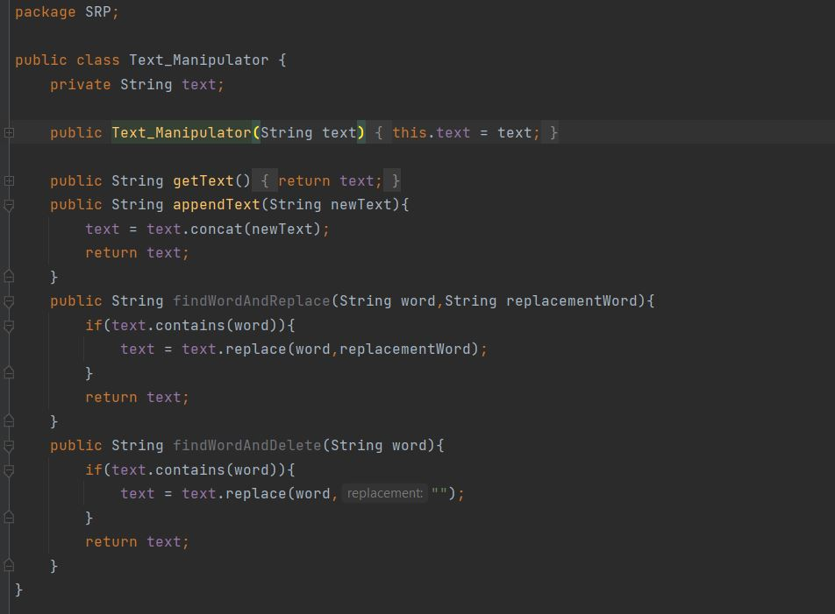

The Text_Manipulator class is now handling only the responsibilities related to the manipulation of the text.

Code snippet of main class:

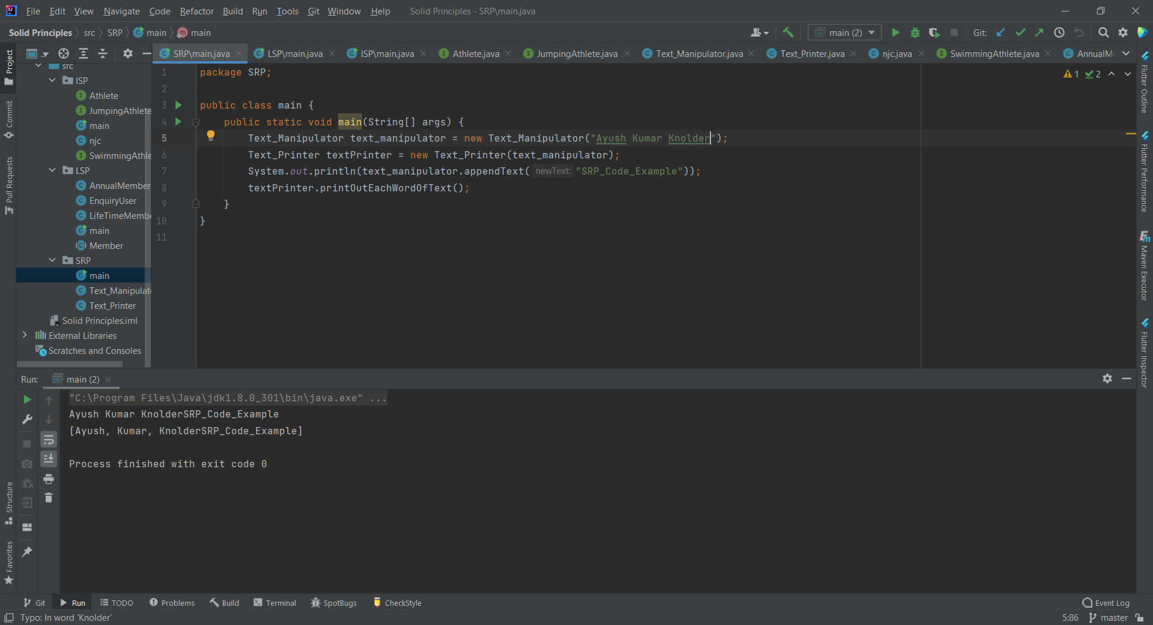

**I.S.P (Interface Segregation Principle)**

The **Interface Segregation Principle** states that clients should not be forced to implement interfaces they don't use. ISP splits interfaces that are very large into smaller and more specific ones so that clients will only have to know about the methods that are of interest to them.

The Interface Segregation Principle represents the “I” of the five [SOLID Principles](http://www.javaguides.net/p/object-oriented-design.html) of [object-oriented programming](http://www.javaguides.net/p/object-oriented-design.html) to write well-designed code that is more readable, maintainable, and easier to upgrade and modify.

The Interface Segregation Principle advocates segregating a “fat interface” into smaller and highly cohesive interfaces, known as “role interfaces”. Each “role interface” declares one or more methods for a specific behavior. Thus clients, instead of implementing a “fat interface”, can implement only those “role interfaces” whose methods are relevant to them.

Let’s understand it with an example:

We will follow the interface segregation principle and refactor the original interface:

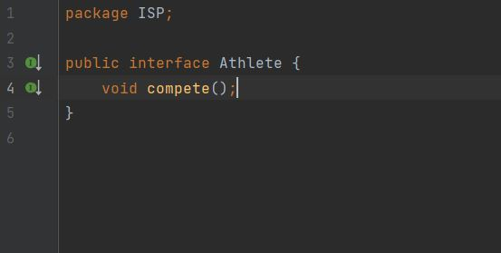

Then we will create two other interfaces —

one for Jumping athletes

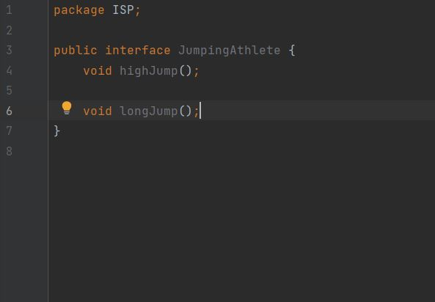

and one for Swimming athletes.

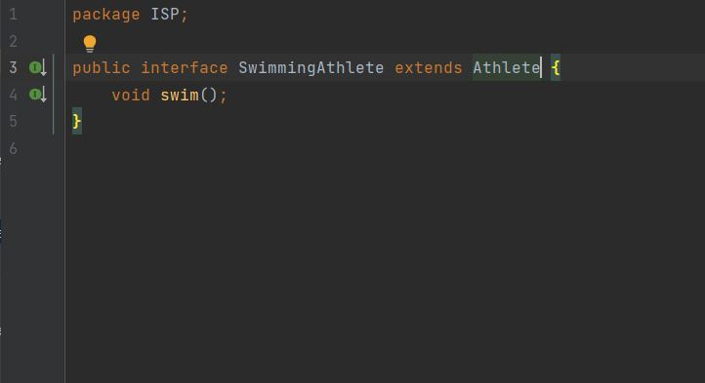

And therefore We will not have to implement actions that he is not capable of performing:

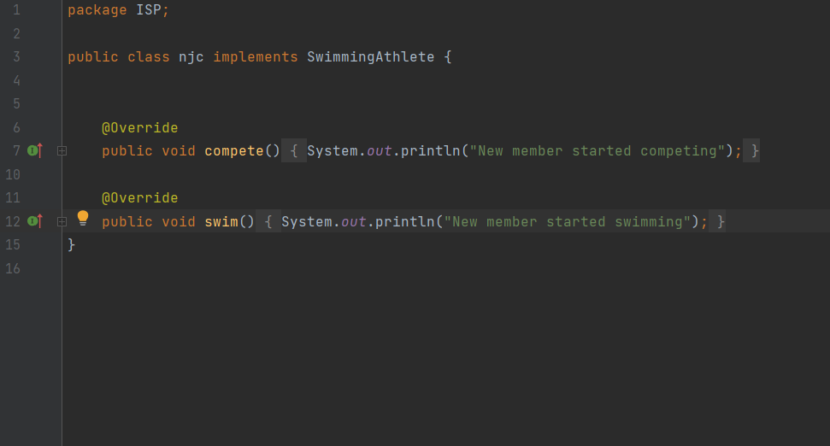

**Summary:-**

So far, we have discussed these three principles and highlighted their goals. They are to help you make your code easy to adjust, extend and test with little to no problems.

Submitted By:

Ayush Kumar